**Hypothesis Testing Exercise**

Sales of products in four different regions is tabulated for males and females. Find if male-female buyer rations are similar across regions.

|  | **East** | **West** | **North** | **South** |
| --- | --- | --- | --- | --- |
| Males | 50 | 142 | 131 | 70 |
| Females | 550 | 351 | 480 | 350 |

1. Check p-value
2. If p-Value < alpha, we reject Null Hypothesis

* All proportions are equal

H0

Ha

* Not all Proportions are equal

Buyer Ratio.mtw

Sol:

α == 0.05 (95% Confidence)

Y == Discrete

X == Discrete

Since there are more than 2 variable we will perform Chi-Square test

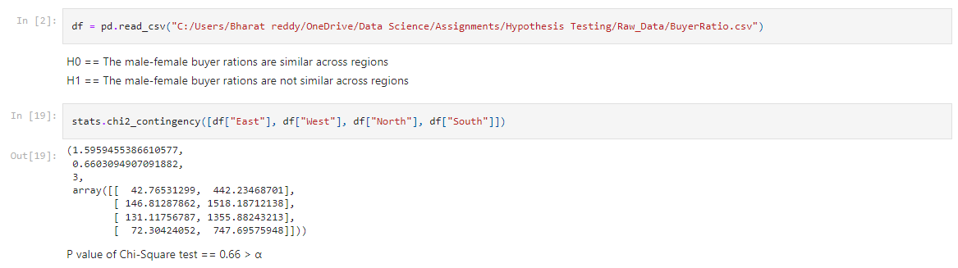

The HO is accepted

Male-Female ration are same across the world